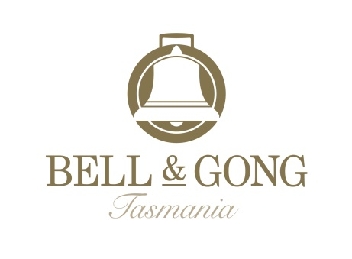
ORDER FORM /
WINE CLUB MEMBERSHIP
WE OFFER:
- A discount of either 20% (12 bottle deliveries) or 10% (6 bottle deliveries) off our website prices on your selected wine deliveries.
- Shipping by courier - costs depends on delivery region:
- Tasmania/Victoria $10/case
- New South Wales $20/case
- Queensland/South Australia/Western Australia $30/case
- Your choice of our selection of wines – straight or mixed cases to order.
- Follow up on Facebook or Instagram for news of new releases and special offers.
Wine Club Members:
- Your selected wine deliveries will be sent around the first week of March, June, September and December for the Quarterly option, or around the first week of June and December for the half yearly option.
YOUR DETAILS:
Name: Company:
Phone (prefer mobile): Email Address:
Billing Address:
Suburb: State: Post Code:
Delivery Address:
Suburb: State: Post Code:

WINES: (Any Combination to 6 or 12) | RRP/Bottle: | QUANTITY: | TOTAL $:
Valleyfield Vineyard Pinot Noir 2025 | $45
Valleyfield Vineyard Pinot Noir 2024 | $45
Flying Mile Longford Pinot Noir | $35
Valleyfield Vineyard Pinot Gris 2025 | $35
Sauvignon Blanc 2025 | $30
Merlot 2025 | $35
Valleyfield Vineyard Chardonnay 2025 | $40
FREIGHT: (See above for cost by State) | $10 / $20 / $30 | 1
FREQUENCY: Once Only Quarterly Half Yearly
Special Delivery Notes (ie. Safe place for Courier to leave):

PAYMENT METHOD: (Visa or Mastercard)
Name on Credit Card:
Credit Card Number: Expiry: CCV:
WINE CLUB Membership Conditions:
- By signing up to the Bell & Gong Wine Club you confirm you are 18 years or older.
- You agree that we may debit your nominated credit card for the relevant amount immediately prior to the despatch of your wine delivery. Your credit card details will be securely stored by us.
- You agree to notify us of any change in your details (including new delivery address and credit card details)
- Wine Club benefits cannot be combined with any other offers.
I would like to become a member of the Bell & Gong Wine Club! YES NO
Signature: | Date:
Bell & Gong, Valleyfield Vineyard, 873 Illawarra Road, Longford Tasmania 7301 www.bellandgong.com
Frances Stewart: 0417 423889 Simon Stewart: 0418 423889 Email: info@bellandgong.com
** Please complete order form and email to info@bellandgong.com **

